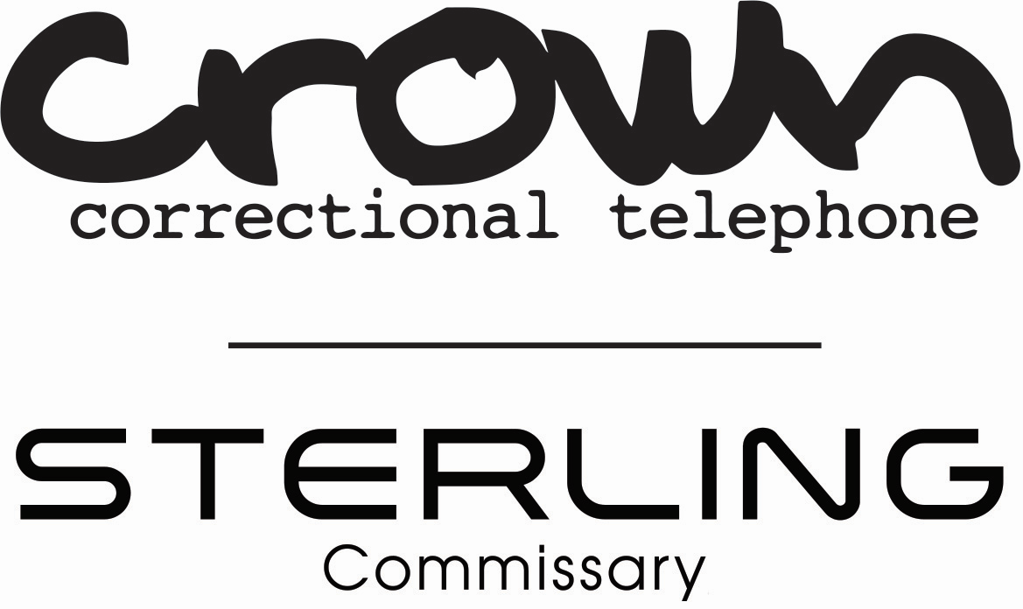
The purpose of this document is to provide the facility, inmates, and inmate contacts answers to commonly asked questions regarding the changes from the NCIC and VendEngine inmate communications platforms to the Cidnet inmate communications platform. Crown will be changing to a new platform at Gilpin, County on 2/27/2023. We would encourage all inmates to let their friends and family know the following information as well as notifying them to use up their phone time prior to this cutover.

Q1. How do friends/ family create an account with Cidnet?
A1. Go to customer.cidnet.net or call 1-888-984-1903.

Q2. How do inmates and friends/ family get a refund for unused balances?
A2. If inmates purchased calling debit time with their inmate balance through Sterling Commissary, the money will be refunded by Sterling/ Crown before switching platforms. We understand that the inmate will be charged $1 to transfer money back to their calling account, therefore, we will offer approximately 2 hours of set time free calling after going live with the Cidnet calling platform (free calls must be made using the wall-mount telephones and not the tablets. Free calling cannot be enabled on the tablets currently). For any unused time through Correct Pay for video visitation and messaging, the family can visit correctpay.com to request a refund, and for any unused phone time balances, the family can call 1-800-943-2189 or visit NCIC.com.

Q3. What are the rates with Cidnet?
A3. Unlike the old platforms, there will be no taxes and fees associated with calling, video calling, or messaging at this time. Unlike traditional inmate calling, Cidnet sells data vs. per minute traditional methods. 1 megabyte of data through Cidnet costs $0.30. For 1 minute of remote video calling (Only offered on the kiosks), approximately 1.4 megabyte of data is used costing roughly $0.40 in a minute of use. One message utilizes approximately 0.33 megabyte of data or $0.10 per message, which will be charged both incoming and outgoing. For a picture message (incoming to the facility only), anywhere from 0.66 megabytes ($0.20) and up are used based on image size. For 1 minute of voice calling utilization, approximately 0.6 megabytes of data is used or roughly $0.18 for one minute of use. The utilization rate will not change regardless of where the inmate is calling. The cinema app is roughly $0.90 per hour of utilization (only offered on the tablets). On all these applications, inmates and contacts will only be charged for what they use. For example, if the inmate does not like a movie, and shuts it off before the end, they will only be charged for what they watched. If a video call gets cut off due to bad connection, the contact will only be charged for the time they were connected.
(This is an approximation, pricing and data usage can vary based on connection.)

Q4. What are the fees associated with Cidnet?
A4. Inmates purchasing data through Sterling Commissary will still be charged $1 per transaction. Inmates who want to purchase calling time should follow the speed dial prompts to get to the commissary menu. Family purchasing data through Cidnet will be charged a $2.99 fee per transaction as well as a credit card processing fee of 5% of the total price.

Q5. Why does family need to create an account with Cidnet?
A5. If family/ friends plan to video visit with an inmate (even the free in-lobby visitations), they must have an account to schedule a visitation. Currently family/ friends must fund any video calls/ visits as well as messaging. The inmates will soon be able to fund their own messaging. How the system works: for video and mail, the family must fund these applications currently. For voice calling, the system will check the inmates balance first. If they have funds available, it will come from their balance. If the inmate does not have funds, but the contact does, the contact will be charged.

Q6. What about collect calling?
A6. Collect calling has not existed for several years. Under traditional inmate calling, a live or automated operator helps the family set up an account and is charged for that connection. This system has no operators. If an inmate tries calling a number, and there are no funds available for the call, the inmate will be prompted to purchase data. The outside contact will be prompted that someone is trying to reach them from the jail and to go to customer.cidnet.net to create an account.

Q7. How does an inmate call outside of the US?
A7. By default, inmates can call Mexico or Canada. For other county requests, staff can create a ticket through the Cidnet admin portal to request calling be turned in for those countries. The country code will have to be entered to complete the call. For example, a US call, a caller enters 1- followed by the number. To call Mexico, the inmate would enter 2- followed by the number.

Q8. Does jailatm.com go away?
A10. No, families can still load money at jailatm.com for inmates to purchase voice calling time as well as commissary products.

Q8. What happens to the messages and pictures in the old system?
A11. The facility will still have access to the old messages and pictures in the old system. The facility at their sole discretion will choose what past photos and messages are uploaded for the inmates after the PDF upload gets developed.

Q9. Will the inmates phone pin and password change?
A9. In some cases, the inmate pin and password will stay the same, and in other instances, the inmate pin and/ or password will change. It is best practice to print new phone pin sheets for each inmate after the conversion is complete and before turning on free calling.

Q10. How does an inmate reach a bondsperson using this platform?
A10. For an inmate to reach a bondsperson when they do not have money on their account, the facility can turn in a ticket through the Cidnet admin portal with a list of approved bondsperson and phone numbers. Cidnet will make them a global contact, meaning any inmate can connect with them at the jail. The bondsperson will have to keep their account funded for the inmates to be able to reach them if the inmate cannot fund their own calls. We would highly recommend that the facility reach out to their approved bonding companies and let them know they will each need to make a customer account at customer.cidnet.net.

